An overview of the economic prospect of Newfoundland's steelmaking industry
[Name]
[Institution affiliation]
[Course]
[Date]

Introduction
Located in the Atlantic Ocean and off the east Canadian Coast, Newfoundland is ranked as the 15th biggest island in the world. In sync with Labrador, Newfoundland falls among the Atlantic provinces in Canada. Newfoundland’s economy heavily depends on natural resources. The most basic economic activity for most of the centuries in Newfoundland had been cod fishing. However, the supplementary activity among most of the fishers was farming. Nevertheless, during the end of 19th and beginning of the 20th centuries, there was an expanded exploitation of the mineral and rich forestry resources in the province. As it is understood, a country’s price remains its ability to carry a cross. For Canada, there is a need to look for a national identity. Apparently, Newfoundland’s burden is about justifying that it should have a good population since capital, natural resources, and labor are very vital as production factors (Atlantic Provinces Economic Council, 2014). Therefore, the report herein provides the Newfoundland’s steelmaking industry economic prospect overview with a conclusion that the industry is not performing at its best and there is a possibility that the companies in such an industry will suffer in the future.
Economic Prospect Overview
In 2015, Newfoundland’s economic activity progressed at higher levels. However, government & consumer expenditure in sync with capital investment maintained at similar levels compared to 2014 (Statistics Canada, 2017). Besides, there was a negative effect on the export section primarily caused by lower oil production. Generally, the year 2015 domestic demand was anticipated to be slightly lower when compared to 2014. As a result, the GDP was anticipated to meet a 2.6% decrease primarily because of decreased export levels as shown in table 1 below:
Table 1: Economic Indicators
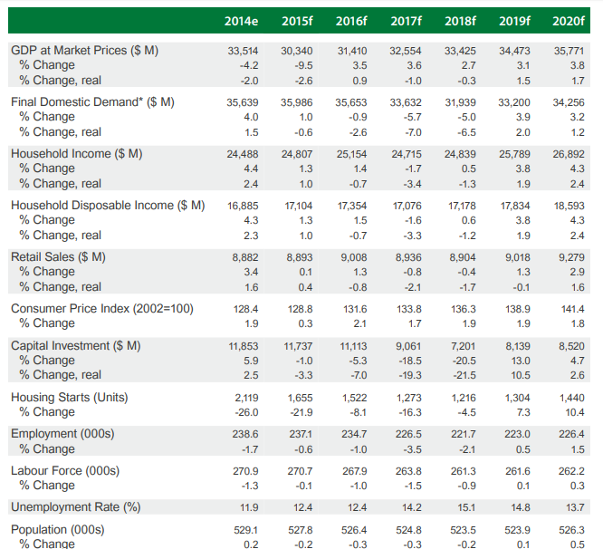
Based on the industry at large, there was a mixed performance in 2016. The oil section recorded decreased production mainly because of operational factors as well as natural reserves’ decline, and lower prices of oil eroding the production value. Also, low prices of iron ore in the mining segment continue exposing difficulty. However, the Canadian Iron Ore Company- the leading player in the industry- had currently finished an expansion project; hence, facilitating advanced productivity and operational performance. The fishing segment, however, has perhaps been affected by the Canadian dollar’s depreciation compared to that of the US as well as the inshore shrimp prices’ record.
The seafood section remains to be a notable provincial economy contributor. On the contrary, the employed number of people in the industry decreased in 2015 because of less processing plant harvesters and workers as well (Statistics Canada, 2017). Preliminary data shows a decrease of 2% in processing employment amounting to 7,721 employees in the year 2015, as compared 7,881 employees the previous year. However, in 2015, fish landings declined to almost 233,200 tonnes, a fall of 4.4% when compared to the previous year as shown in the chart below:
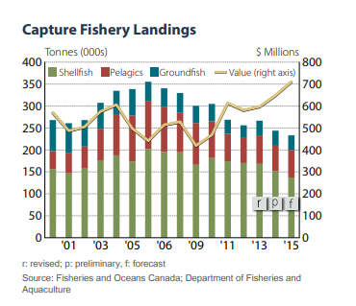
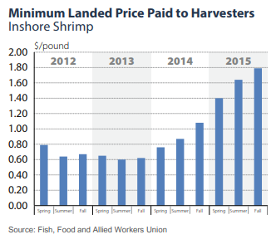
Such a landings’ decrease primarily resulted from the fewer shellfish handlings. As it can be seen from the chart above, the shellfish landings in 2015 went down by 9.4% amounting to 137,301 tonnes, primarily from the low harvesting of the type of the fish and it declined for over 40%. Nevertheless, in 2015, there were 69,401 tons of shrimp landings, representing a 2.8% decrease when compared to 2014 because of closing the shrimp fishery in NAFO Division 3L.
Nevertheless, the manufacturing section has also been affected by a start-up boost in terms of production arising from the Vale’s facility for nickel processing whereas lumber and newsprint production remains considerably stable. Notwithstanding, the construction section is constantly impacted by the main project development supporting high income and employment levels (Statistics Canada, 2017). Apparently, the tourism market is on a continuous dampening on the previous benefits since automobile visitation and the non-resident air had a 2% decrease during the first eight months in the year 2015. The provincial exports’ value declined by 17.6% in the year 2015 primarily because of lower prices of oil and production as well. The production of oil dropped by 16% in 2016 due to decreased output among the three projects- White Rose, Hibernia, and Terra Nova. This, together with a 46% decrease in Brent crudes average price, led to an almost a 50% decrease in the oil exports’ value.
Conclusion
Despite the fact that the long-term results look promising, the down-winding of the various major projects’ development in the short-term, especially the Muskrat and Hebron Falls, are expected to decrease the capital expenditure in the coming few years (Holden, & Canada 2017). Moreover, low prices of the commodity have perhaps deadened the resource development in the short-term and are anticipated to continue with the same trend. Collectively, such aspects are anticipated to negatively affect the capital investment spending in Newfoundland province. In the coming few years, investment is anticipated to decrease to $7.2 billion from $11.7 billion as it was in 2015 as shown in the graph below:
Graph 1: Capital Investment
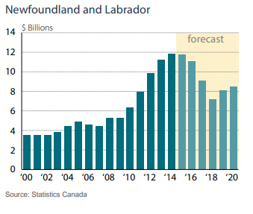
As it is shown in the graph above, decreased mining and oil output in 2015 provided an exports’ decrease and it translated into a real GDP decrease of 0.9%. Besides, as Muskrat and Hebron Falls almost attained their completion, a decrease in the investment capital was evident. As a result, there was a decrease in the employment rate (Holden, & Canada 2017). Similarly, low prices of oil continued to dampen Western Canada’s development activity; hence, impacting the employment of various residents in Newfoundland commuted to Western Canada. Such aspects are expected to worsen both consumption and income growth. Apparently, the final domestic demand also anticipates a 2.6% decrease.
In the years 2017 and 2018, the economic growth was slowed by capital investment decreases. Most of the primary economic reflectors were anticipated to decrease in such a period. Since growth is forecast to be constrained in the near future, it remains significant understanding that it happened at a period when there were highest incomes according to Newfoundland’s history. Finally, given such a manageable time of booming investment capital resulting from the main project development, a retrenchment period was witnessed.

Appendixes
Appendix 1:
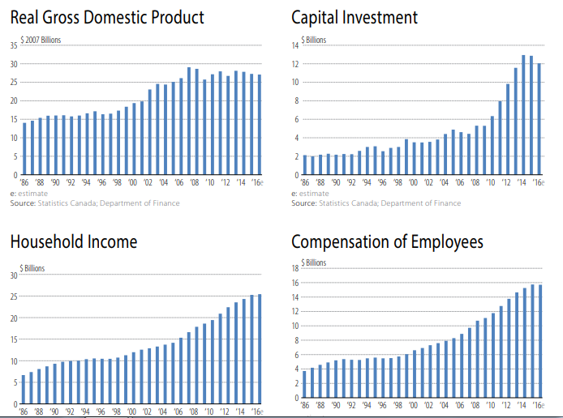
Appendix 2:
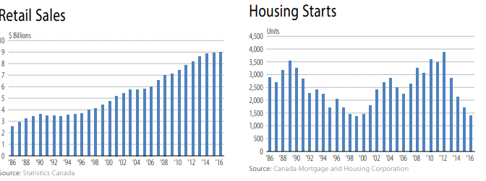
Appendix 3:
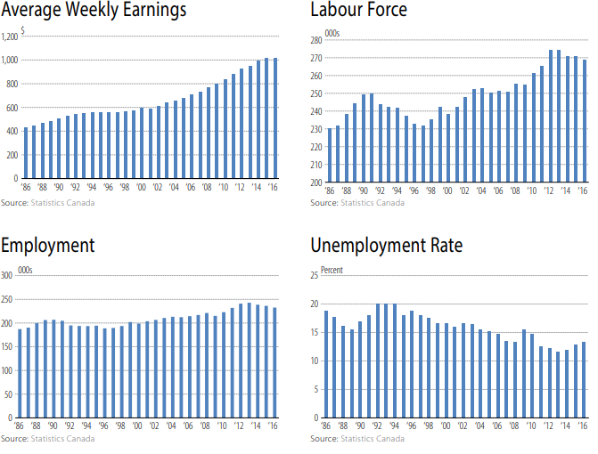
Appendix 3:
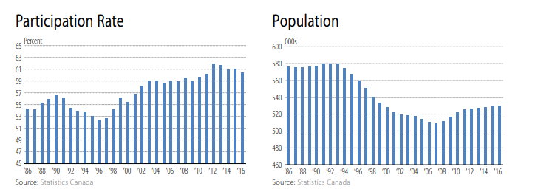

References
Atlantic Provinces Economic Council. (2014). Steelmaking in the Atlantic Provinces: A commentary. Halifax, N.S.: Atlantic Provinces Economic Council.
Holden, M., & Canada. (2017). Per capita Gross Domestic Product: An appropriate measure of living standards: the case of Newfoundland and Labrador. Ottawa: Library of Parliament, Parliamentary Research Branch.
Statistics Canada. (2017). Canada. Ottawa: Statistics Canada.

